BITZER Kühlmaschinenbau GmbH
Eschenbrünnlestraße 15
71065 Sindelfingen // Germany
Tel +49 (0)70 31 932-0
Fax +49 (0)70 31 932-147
pr@bitzer.de // www.bitzer.de

Seite // Page 1 von // of |  | 6

Seite/Page 1 von/of |  | 1
An/To | 0 70 31/932

Unser Zeichen // Our Ref.
Abs. // Sender |  | Patrick Koops
Abt. // Dept. |  | Public Relations
Tel.-Dw. // Ext. |  | +49 (0)70 31 932-43 27
 | Fax-Dw. // Ext. | +49 (0)70 31 932-5 43 27
 | E-Mail | patrick.koops@bitzer.de
 | Datum // Date | 04.05.2017

Imitation oils are coming onto the market under the BITZER logo in Vietnam and Korea

Fake oils discovered in Asia

Sindelfingen, 4 May 2017. The long-standing company BITZER warns users against imitation oils. In Vietnam and Korea, counterfeiters partly disguised their imitations with the logo and name of the specialist for refrigeration compressors. These forgeries can lead to compressor breakdown, in contrast to the use of BITZER Original Refrigeration Oils.

Product pirates not only sell counterfeit compressors, they also bring low-quality oils onto the market. In Asia, for example, counterfeiters partly disguised their imitations with the BITZER name and logo, presenting major risks. BITZER recently discovered several fake oils in Vietnam: a local company has illegally been declaring and selling containers with low-quality oil as original products from BITZER. According to the label, the high-quality oils B320SH, BSE32, BSE170 and B100 should be in the containers. However, they contained oils of inferior quality whose chemical formulation differs greatly from the high quality of the originals.
BITZER has investigated the counterfeiting and expressly warns customers against the possible risks associated with their use. The viscosity characteristics, moisture content and chemical formulation are very different from the original products.

Programmed damage
Using the fake product can lead to insufficient lubrication of compressors, chemical reaction, destruction of elastomers and thus to great damage. In the imitation oil of the type BSE170, the moisture content exceeded the permissible values significantly. It was three times higher than the permissible value. High moisture content in polyolester oils like BSE170 is particularly critical because it leads to hydrolysis with the result of acid formation in the refrigerant circuit. This in turn causes copper plating and thus damage of critical moving parts like roller bearings as well as possible motor burn-out. This can in consequence trigger very high costs for compressor exchange and measures for system dehydration and acid catching.

Original BITZER Refrigeration Oils
Original BITZER lubricants feature lowest moisture content (lower than specified in standards) and specific properties optimised for BITZER compressors. Their chemical compatibility is extensively tested including distinct compressor construction materials introduced for use with the latest low-GWP HFOs and HFO/HFC blends. Due to their specific tribological characteristics, BITZER oils guarantee highest service life of the compressors. The outstanding lubricity and superior viscosity/temperature behaviour ensure reliable compressor operation and sufficient oil circulation in the circuit. BITZER Refrigeration Oils are subject to BITZER Quality Assurance and are delivered in metal packages which allow no moisture to ingress, even after longer periods of storage. Furthermore, safety data sheets are available as standard in several languages for all BITZER oils.

Only originals are safe
The specialist for refrigeration compressors condemns product piracy and warns against the associated risks. The use of counterfeit oils has a negative impact on the performance, safety and service life of BITZER compressors. Users should avoid these risks. In the end, the consequences of supposedly cheap forgeries are by far more expensive than the expected savings. The Original Refrigeration Oils certified by BITZER offer users more safety and have positive effects on the compressor’s life. Customers who have concerns about the origin of their lubricant are invited to contact their local BITZER representative for advice.

■

The BITZER Group is the world’s largest independent manufacturer of refrigeration compressors with sales companies and production sites for reciprocating, screw, and scroll compressors as well as heat exchangers and pressure vessels all over the globe. In 2016, 3,400 employees generated sales of €680 million.

Overview of images
Images may only be used for editorial purposes. This usage is free of charge if "Photo: BITZER" is given as the source and a complimentary copy is forwarded to us. Changes to the images – apart from cropping to the main motif – are not permitted.
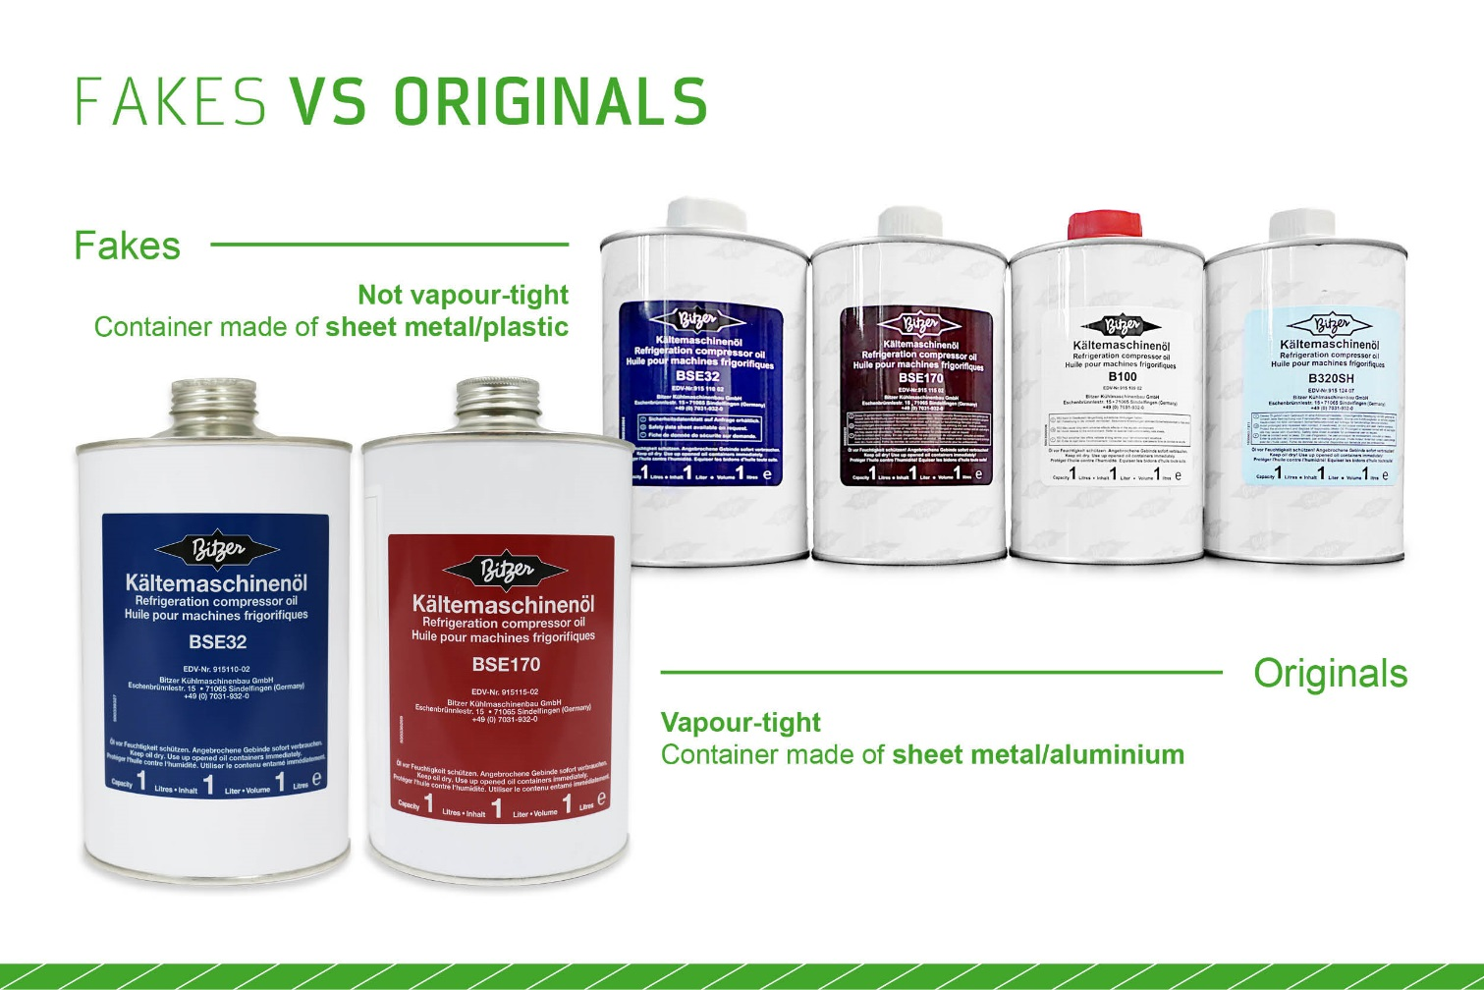

Image 1: Users should always use original oils. These are specifically designed for BITZER compressors and meet the highest standards
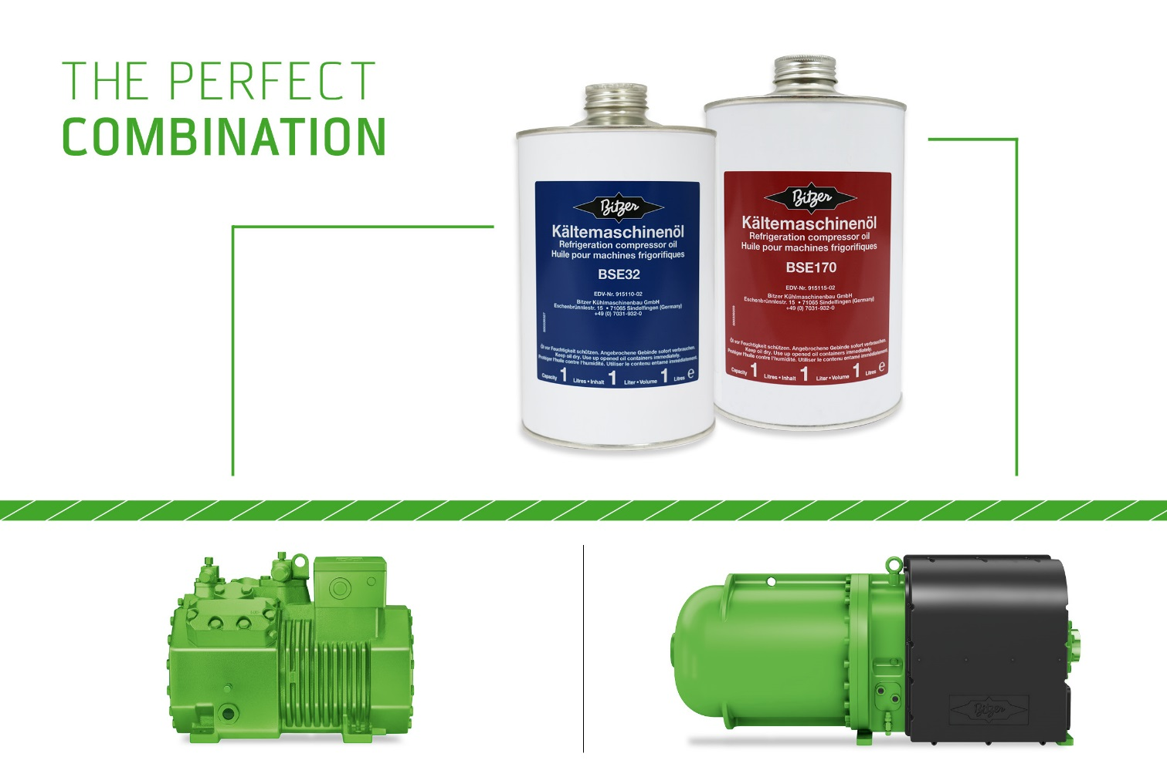

Image 2: BSE32 matches the use of HFKW and HFO refrigerants in BITZER reciprocating compressors, whereas BSE170 is used in BITZER screw compressors
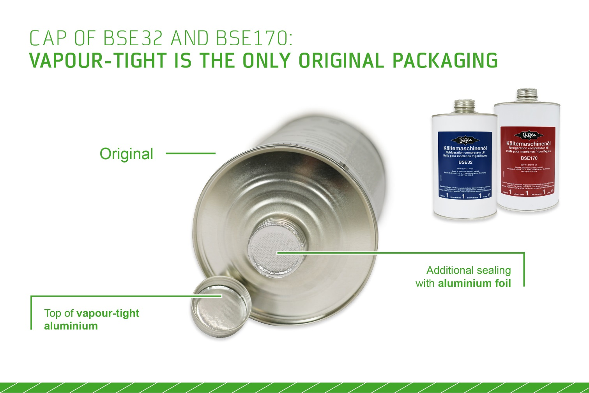

Image 3: The vapour-tight packaging (here: caps of BSE32 and BSE170, used in Europe) gives evidence of the oil being a BITZER Original

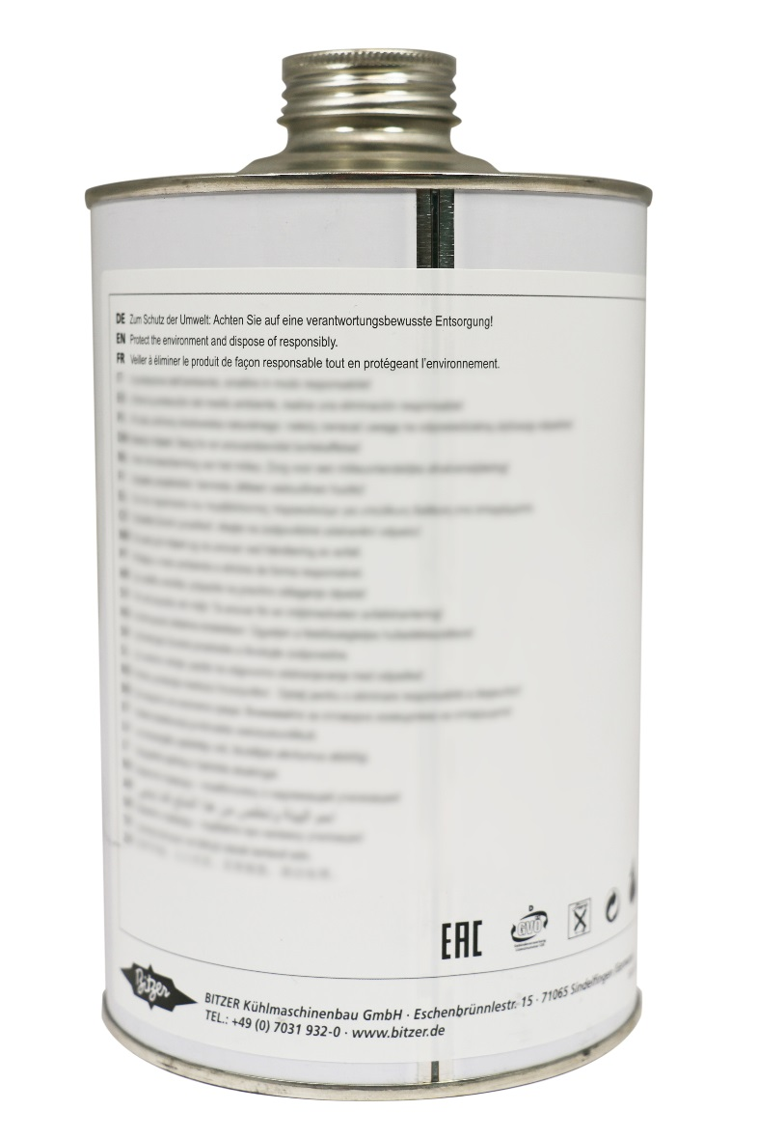

Image 4: The warning labels should always be taken special note of

